Angular 5 with Node, Express & Mongo DB - Case Study

Create a “Movie App” wherein movies could be maintained according to genres like Fiction, Drama and Satire. There is also a search option allowing to search for movies.

Refer below screen shot: Created in Angular 5

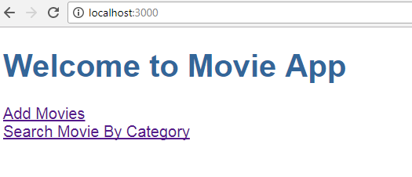

a. When the user clicks on “Add Movies” -> Allows a User to add a movie.

The user can add movie(s) depending on Genre (drop-down list loaded with values [Drama, Fiction, Satire])

The user could add multiple movies. On Adding Movies will be added in Mongo Db with the help of Node & Express (Restful-API). Use Node & Express RestFul-API with Mongo Db concept Refer below screen shot:

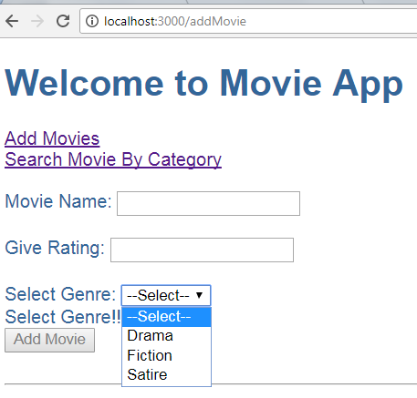

Refer below screens for validations:

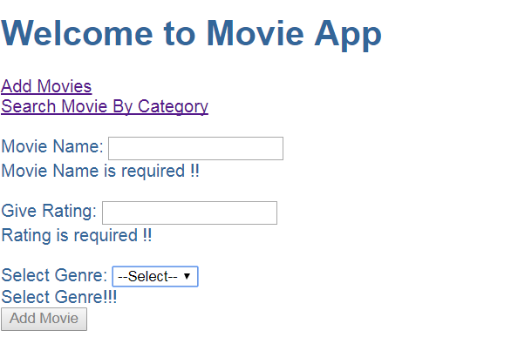

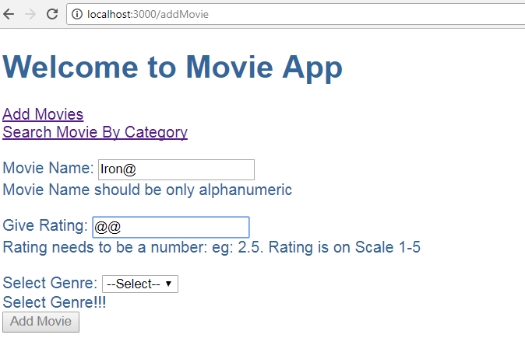

1. When the user clicks on “Search Movie By Category” -> Allows user to search movie(s) by Category. [Depending on Genre (Drama, Fiction, Satire)]

There could be more than one movies depending on same Genre. Refer below screen shots:

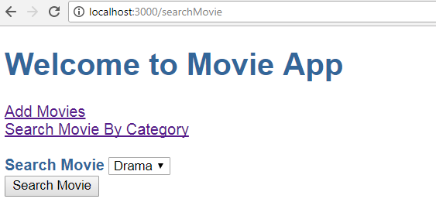

Thus if Searching Movie on ‘Drama’ displays below Result:

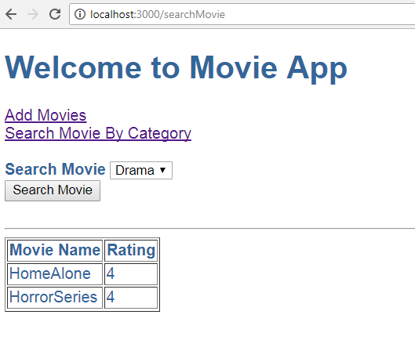

Thus if Searching Movie on ‘Fiction’ displays below Result:

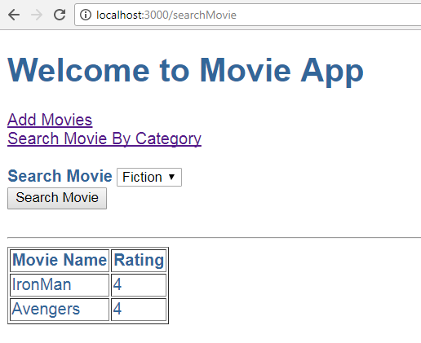

**Note:**

1. In above assignment movies are added via “Add Movies” and Searched via “Search Movie By Category”. ***These are different components.***
2. Make use of Angular 5 Forms.
3. Make use of services.
4. Make use of Router Module. Which should be created as a separate module and included in the main App Module.
5. Use Node & Express restful API & Mongo DB concept to add movies & search movies.
6. All adding & searching movies done through MongoDb